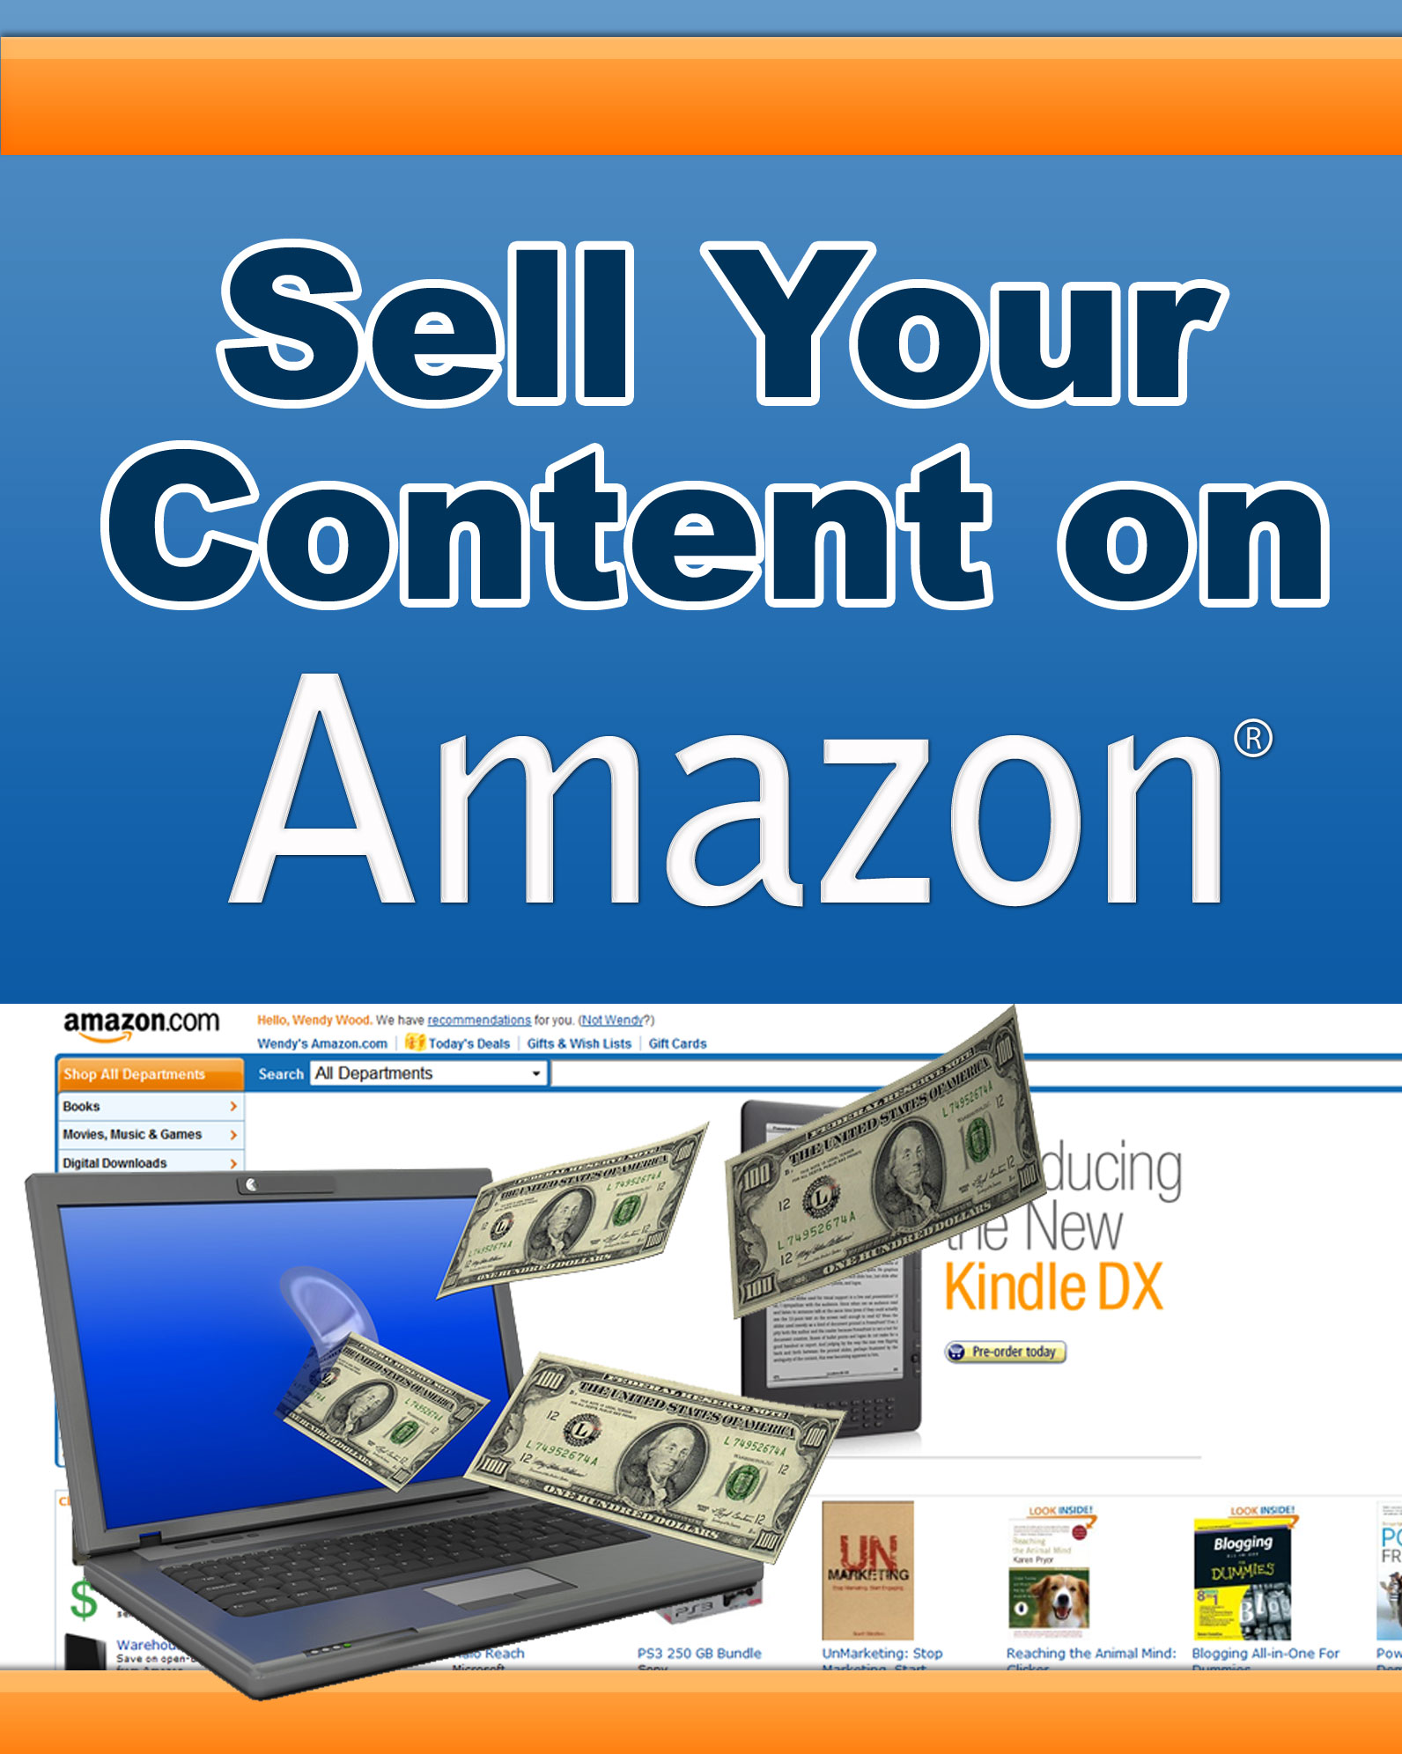
Sell Your Content on Amazon

Getting your content on Amazon isn’t difficult – In fact, you could have your content up and for sale in as little as two weeks! What formats can you sell on Amazon and how do you get your content on Amazon? Read this report carefully to find out.
Why Sell Your Content on Amazon?
There are many reasons why you may want to sell your content on Amazon.
The first and more important reason is that it brings you free traffic. Amazon is one of the most highly trafficked websites in the world. Millions of visitors who could benefit from your content are signing into Amazon every day.
Don’t you want a piece of that pie?
Another great reason to get on Amazon is credibility. Even if you never sell a single copy on Amazon, simply being able to say on your website or in person that your book is for sale on Amazon builds credibility.
Amazon is a brand name that people recognize. There’s a lot of credibility that goes along with having your book or product on Amazon. It takes you from being just one of the many unknown eBook publishers to someone with credibility.
Most people don’t realize how easy it is to get on Amazon. There’s a high perceived value to being on Amazon.com
Finally, it costs you nothing once you’re up and running. Yes, getting on Amazon does cost a little bit of money to get started ($150 to $400, approximately.) But once you’re up and running, it’s just a free advertisement for you. It will basically be up there forever.
Who Can Sell Content on Amazon?
Really anyone can sell content on Amazon. You don’t need to be a recognized expert on the subject. Literally anyone who understands and follows the process to get their content on Amazon can do so.
That means that you! Even if you’ve only sold a few copies of your eBook or audio guide, but believe that if you got more exposure people will be interested, you can get your eBook on Amazon and see what happens!
There are almost no requirements on who can publish their content. The only real rule is that you own the copyright.
In other words, you can’t publish a PLR book and claim it as your own. But if it’s your own original content, you can put it on Amazon.
What Formats Can You Sell on Amazon?
There are many formats you can sell your content in on Amazon.
eBook Format
One great way to make money by selling your eBook is to sell it in the Kindle format.
Amazon’s Kindle was the first eBook reader to really take off. It features a special screen that makes it so that it doesn’t hurt the eyes when it’s read for extended periods of time. It was designed especially for people to read books on.
What’s great about releasing your content for the Kindle is that there are millions of users who are browsing the Kindle store every month, looking to buy. They’re ready to fork over their money if you could just catch their eye.
Note that although you used to be able to publish eBooks just for PC downloads in the MobiPocket that format was retired when the Kindle was released.
Publishers who were already registered with MobiPocket could still publish eBooks that were downloadable just to PCs, but that program no longer accepts new publishers.
Videos in DVD Format
You can also sell educational videos in DVD format.
Amazon doesn’t accept digital download videos, but you can easily package your videos on a DVD format and have it printed on demand.
That way, you don’t have to pay any upfront printing fees. Instead, whenever someone orders your DVDs, a portion of that money goes to the printing company who prints your DVDs only when they’re needed.
Software
Finally, you can sell software on Amazon.
Most people won’t buy software from you on Amazon unless they’ve heard of you or you’re offering something truly unique.
On the other hand, having your software listed on Amazon is again a great way to build credibility.
Now that we’ve talked about the many different types of content you can list on Amazon, let’s talk about the actual process of getting your content listed on Amazon.

Getting an ISBN Number
In order to sell your content on Amazon, you must have an ISBN number.
ISBN stands for an “International Standard Book Number.” Yes, even with an eBook, you must have an ISBN number. Even if you’re selling just for the Kindle, you need an ISBN number.
ISBN allows Amazon’s system to identify your book easily. It’s an important part of their system that cannot be bypassed.
So how do you get an ISBN number?
It’s easy – Just go to ISBN.org and submit an application. The whole process will probably take you about a week. The cost is $125 plus tax at the time of this writing.
There are several “add on” packages you can buy from ISBN.org. You really don’t need them – You just need the ISBN number so you can list your product on Amazon.
Even if you already have an ISBN number for the physical edition of a book, you’ll need a new one for the online edition.
The online book is considered a different edition than the physical book and therefore requires a different ISBN.
Once you get your ISBN number, proceed to the next step.
Creating Your Cover
Once you have your ISBN number, it’s important that you have a great book cover.
In eBook sales, a good eBook cover isn’t as important. The primary “pulling power” comes from your headline or your existing credibility.
That isn’t the case with Amazon sales. On Amazon or the Kindle, your book’s image is your primary grabber.
Much like how having a good headline is important in print or the internet, having a great cover will make all the difference in your online sales.
Here’s what makes a truly killer eBook cover:
- First and foremost, it should catch attention. It should make the browser STOP what they’re doing and look at your book cover.
- It should convey what your book is about.
- It should convey what’s in it for your reader the moment you see it. In other words, it should be clear to them why they should click on your book cover to learn more about your book.
- It should look professional.
- It should convey a “vibe.” The vibe you want to convey depends entirely on your book. It could be a classy vibe, a radical vibe, an artsy vibe, whatever is appropriate. But the viewer should get a feeling from looking at your book cover.
Unless you’re a professional designer, chances are you’ll want to have a designer create your eBook cover.
If you’ve already made money online and have a name for yourself, then hire an experienced designer to really create something killer.
If you’re just starting out, then get a designer from eLance for $100 to $200 to design a simple cover for you. Perhaps you could come up with most of the idea yourself and just have it implemented.

For eBooks: Register as a Digital Text Platform Publisher
To publish your eBook on Amazon, the first step is to get an account in Amazon’s Digital Text Platform (DTL).
To register for your account, just go to:
https://dtp.amazon.com
Complete all your account’s information by clicking on Account Information in the upper right.
Once you’ve completed your account information, add your first title by clicking on “Add Title.”
Go through the whole process of filling out what your books is about, the title, the description, ISBN, cover image and so on.
Then click save and continue. Fill out the information rights and pricing. Upload your eBook and wait for Amazon’s approval.
The approval process generally takes around 2 weeks, though it could be faster or it could take longer.
Make sure you double check all the information before you hit submit.
How Much Does it Cost?
Amazon takes a 75% commission. If you sell your eBook for $20, you get to keep $5.
This is a pretty steep commission, no doubt about it. However, would you rather get 25% of something, perhaps even a large volume of sales, or 100% of nothing?

Moving to Physical Products
Although this report is primarily about selling digital content, I want to say a quick word about moving to physical.
Although Kindle has a user base of millions, there are still far more people browsing Amazon’s actual site than the Kindle’s.
You can’t submit just an eBook to Amazon anymore now that they’ve closed their MobiPocket platform. However, creating a Print on Demand book is easier than you think.
Just go to one of the many Print on Demand sites on the web, register a new ISBN and you’re set to go. You can then setup your book on Amazon and reach millions that you wouldn’t have reached otherwise.
The commission for selling a physical book is less than a downloadable book: It’s a $0.99 fee per sale plus 15% commission.
It takes a little bit of work, but the exposure could easily pay for itself and then some.
Audio, Video and Software Content
Audio books are published in two different ways. First, you can publish them as audio CDs. In which case the process is very similar to publishing a regular book.
If you’re publishing a downloadable audio book, go through Audible.com, Amazon’s audio book subsidiary. They purchased Audible a while back and Audible is now a part of Amazon.
If you want to publish video content, use print on demand DVDs. You cannot publish just plain downloadable video content.
Note: Technically Amazon has a feature called “Video on Demand,” but that’s more for popular TV shows and movies. There isn’t a “downloadable video content” type of section.
For software content, you can again do physical or digital download. Create an Amazon seller’s account and follow the steps outlined in the process.
Should You Sell Your Content on Amazon?

Selling your content on Amazon isn’t easy, but it isn’t difficult either. The investment on your part is about 5 to 10 hours of work plus about $150 to $400 for the ISBN numbers, book covers and any other investments you need to make.

If you have a compelling cover and title, if you have a bit of a name for yourself already or if you have something very unique to say, you could become the next Amazon bestseller.

Give it a shot – The investment is small and there’s a lot to gain.

